Sri Lanka Institute of Information

Technology

**Introduction to Cyber Securit**

**y**

**-**

**IE202**

**2**

Lab Submission 0

7

**IT22151056**

**De Silva K.R.K.D**

Task 01 encryption and Decryption using different ciphers and modes

**1.Encrypt using cbc mode.**

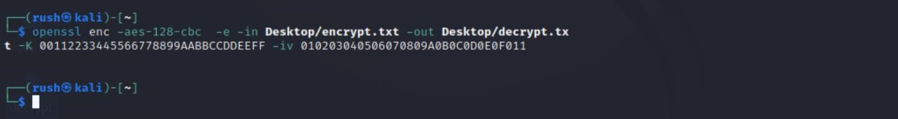

Plaintext file

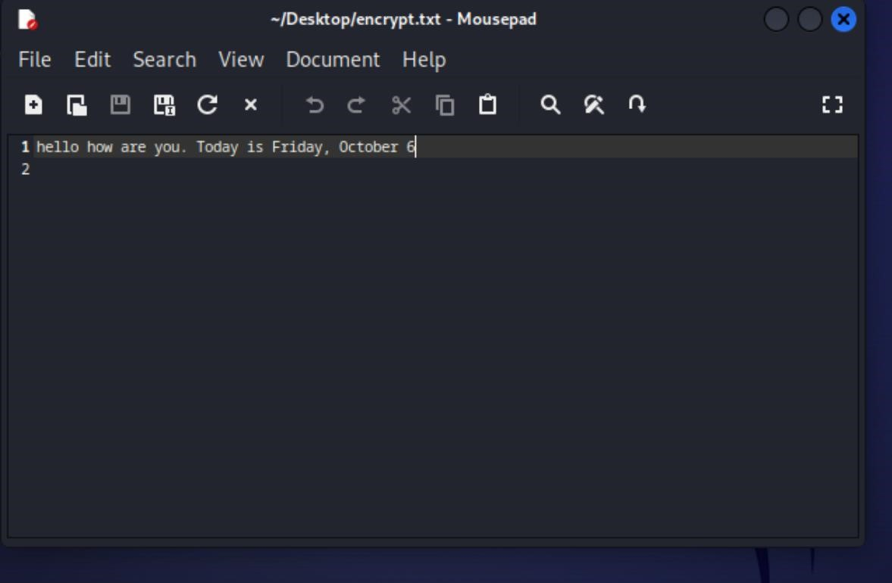

Decrypted file

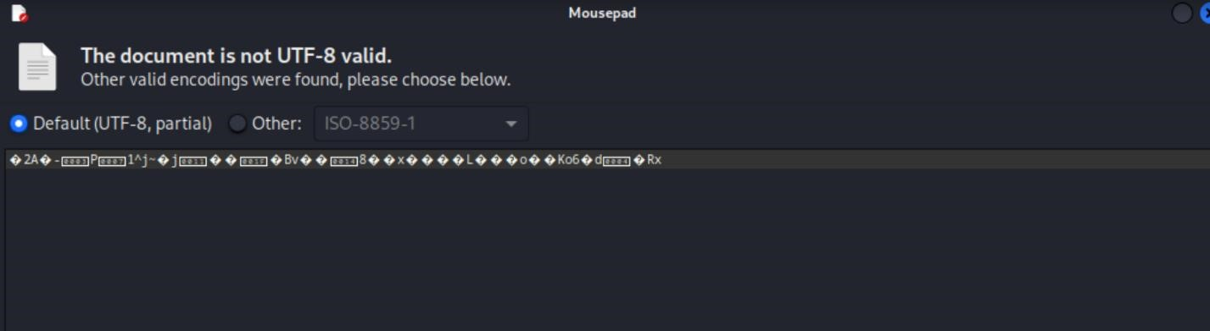

# 2.Encrypt using CFB mode



Plaintext file



Encrypted File

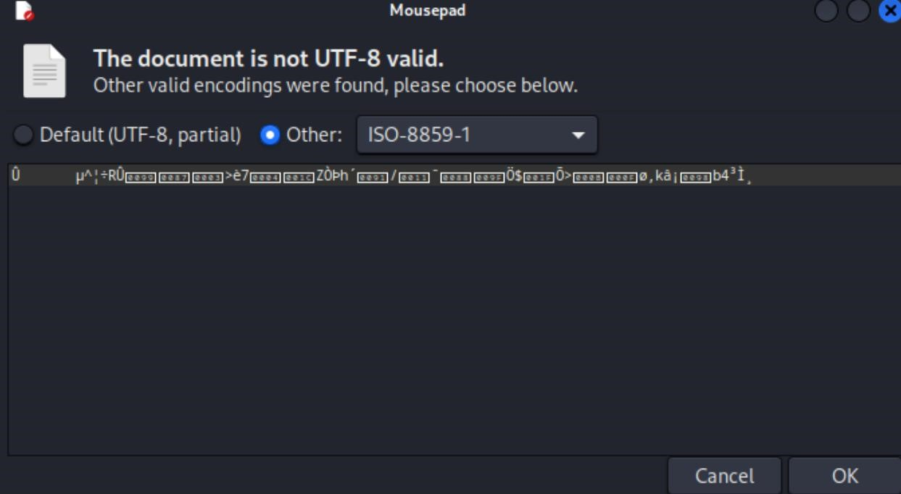

# 3.Encrypted Using CTR mode

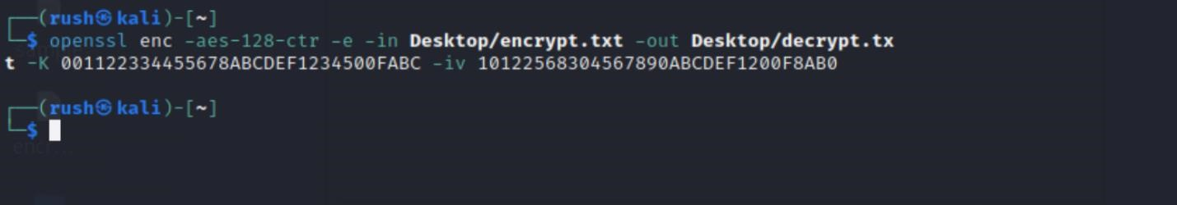

Plaintext file

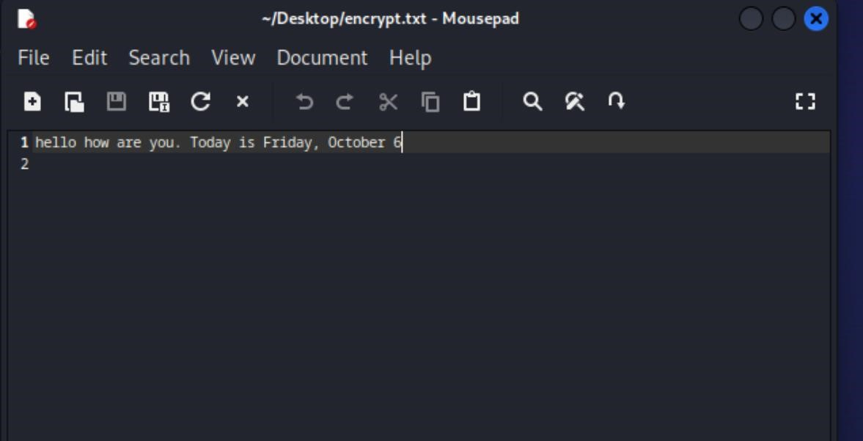

Encrypted File

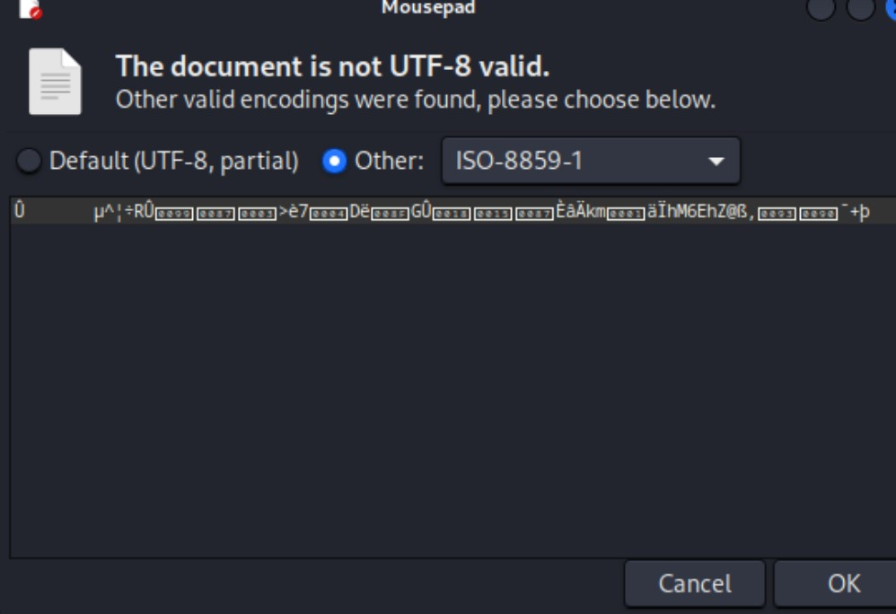

Here, when different modes are used, even if the same key and iv value are used, different decryption values are obtained.